What is Cloud Computing

The term cloud refers to a network or the internet. It is a technology that uses remote servers on the internet to store, manage, and access data online rather than local drives. The data can be anything such as files, images, documents, audio, video, and more.

There are the following operations that we can do using cloud computing:

* Developing new applications and services
* Storage, back up, and recovery of data
* Hosting blogs and websites
* Delivery of software on demand
* Analysis of data
* Streaming videos and audios

Why Cloud Computing?

Small as well as large IT companies, follow the traditional methods to provide the IT infrastructure. That means **for any IT company, we need a Server Room that is the basic need of IT companies**.

In that server room, there should be a database server, mail server, networking, firewalls, routers, modem, switches, QPS (Query Per Second means how much queries or load will be handled by the server), configurable system, high net speed, and the maintenance engineers.

To establish such IT infrastructure, we need to spend lots of money. To overcome all these problems and to reduce the IT infrastructure cost, Cloud Computing comes into existence.

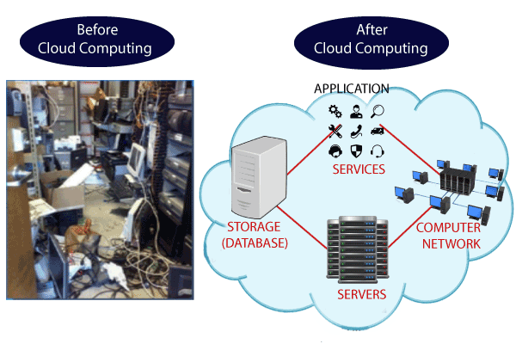

Characteristics of Cloud Computing

The characteristics of cloud computing are given below:

**1) Agility**

The cloud **works in a distributed computing environment**. It shares resources among users and works very fast.

**2) High availability and reliability**

The availability of servers is high and more reliable because the **chances of infrastructure failure are minimum**.

**3) High Scalability**

Cloud offers **"on-demand" provisioning of resources on a large scale**, without having engineers for peak loads.

**4) Multi-Sharing**

With the help of cloud computing, **multiple users and applications can work more efficiently** with cost reductions by sharing common infrastructure.

**5) Device and Location Independence**

Cloud computing enables the users to access systems using a web browser regardless of their location or what device they use e.g. PC, mobile phone, etc. **As infrastructure is off-site** (typically provided by a third-party) **and accessed via the Internet, users can connect from anywhere**.

**6) Maintenance**

Maintenance of cloud computing applications is easier, since they **do not need to be installed on each user's computer and can be accessed from different places**. So, it reduces the cost also.

**7) Low Cost**

By using cloud computing, the cost will be reduced because to take the services of cloud computing, **IT company need not to set its own infrastructure** and pay-as-per usage of resources.

**8) Services in the pay-per-use mode**

Application Programming Interfaces**(APIs) are provided to the users so that they can access services on the cloud** by using these APIs **and pay the charges as per the usage of services**.

# **Advantages and Disadvantages of Cloud Computing**

## Advantages of Cloud Computing

As we all know that Cloud computing is trending technology. Almost every company switched their services on the cloud to rise the company growth.

Here, we are going to discuss some important advantages of Cloud Computing-

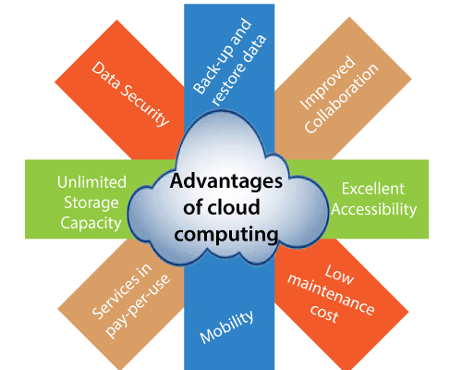

### **1) Back-up and restore data**

Once the data is stored in the cloud, it is easier to get back-up and restore that data using the cloud.

### **2) Improved collaboration**

Cloud applications improve collaboration by allowing groups of people to quickly and easily share information in the cloud via shared storage.

### **3) Excellent accessibility**

Cloud allows us to quickly and easily access store information anywhere, anytime in the whole world, using an internet connection. An internet cloud infrastructure increases organization productivity and efficiency by ensuring that our data is always accessible.

### **4) Low maintenance cost**

Cloud computing reduces both hardware and software maintenance costs for organizations.

### **5) Mobility**

Cloud computing allows us to easily access all cloud data via mobile.

### **6) IServices in the pay-per-use model**

Cloud computing offers Application Programming Interfaces (APIs) to the users for access services on the cloud and pays the charges as per the usage of service.

### **7) Unlimited storage capacity**

Cloud offers us a huge amount of storing capacity for storing our important data such as documents, images, audio, video, etc. in one place.

### **8) Data security**

Data security is one of the biggest advantages of cloud computing. Cloud offers many advanced features related to security and ensures that data is securely stored and handled.

## Disadvantages of Cloud Computing

A list of the disadvantage of cloud computing is given below -

### **1) Internet Connectivity**

As you know, in cloud computing, every data (image, audio, video, etc.) is stored on the cloud, and we access these data through the cloud by using the internet connection. If you do not have good internet connectivity, you cannot access these data. However, we have no any other way to access data from the cloud.

### **2) Vendor lock-in**

Vendor lock-in is the biggest disadvantage of cloud computing. Organizations may face problems when transferring their services from one vendor to another. As different vendors provide different platforms, that can cause difficulty moving from one cloud to another.

### **3) Limited Control**

As we know, cloud infrastructure is completely owned, managed, and monitored by the service provider, so the cloud users have less control over the function and execution of services within a cloud infrastructure.

### **4) Security**

Although cloud service providers implement the best security standards to store important information. But, before adopting cloud technology, you should be aware that you will be sending all your organization's sensitive information to a third party, i.e., a cloud computing service provider. While sending the data on the cloud, there may be a chance that your organization's information is hacked by Hackers.

# **Cloud Computing Architecture**

As we know, cloud computing technology is used by both small and large organizations to **store the information** in cloud and **access** it from anywhere at anytime using the internet connection.

Cloud computing architecture is a combination of **service-oriented architecture** and **event-driven architecture**.

Cloud computing architecture is divided into the following two parts -

* Front End
* Back End

The below diagram shows the architecture of cloud computing -

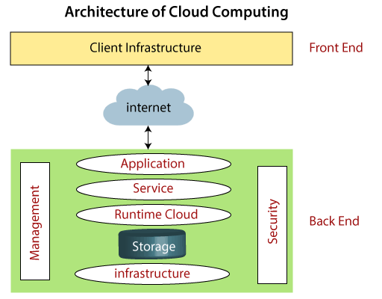

### **Front End**

The front end is used by the client. It contains client-side interfaces and applications that are required to access the cloud computing platforms. The front end includes web servers (including Chrome, Firefox, internet explorer, etc.), thin & fat clients, tablets, and mobile devices.

### **Back End**

The back end is used by the service provider. It manages all the resources that are required to provide cloud computing services. It includes a huge amount of data storage, security mechanism, virtual machines, deploying models, servers, traffic control mechanisms, etc.

#### **Note: Both front end and back end are connected to others through a network, generally using the internet connection.**

## Components of Cloud Computing Architecture

There are the following components of cloud computing architecture -

**1. Client Infrastructure**

Client Infrastructure is a Front end component. It provides GUI (Graphical User Interface)  to interact with the cloud.

**2. Application**

The application may be any software or platform that a client wants to access.

**3. Service**

A Cloud Services manages that which type of service you access according to the client’s requirement.

Cloud computing offers the following three type of services:

**i. Software as a Service (SaaS) –**It is also known as **cloud application services**. Mostly, SaaS applications run directly through the web browser means we do not require to download and install these applications. Some important example of SaaS is given below –

**Example:** Google Apps, Salesforce Dropbox, Slack, Hubspot, Cisco WebEx.

**ii. Platform as a Service (PaaS) –** It is also known as **cloud platform** **services**. It is quite similar to SaaS, but the difference is that PaaS provides a platform for software creation, but using SaaS, we can access software over the internet without the need of any platform.

**Example:** Windows Azure, Force.com, Magento Commerce Cloud, OpenShift.

**iii. Infrastructure as a Service (IaaS) –**It is also known as **cloud infrastructure services**. It is responsible for managing applications data, middleware, and runtime environments.

**Example:** Amazon Web Services (AWS) EC2, Google Compute Engine (GCE), Cisco Metapod.

**4. Runtime Cloud**

Runtime Cloud provides the **execution and runtime environment** to the virtual machines.

**5. Storage**

Storage is one of the most important components of cloud computing. It provides a huge amount of storage capacity in the cloud to store and manage data.

**6. Infrastructure**

It provides services on the **host level**, **application level**, and **network level**. Cloud infrastructure includes hardware and software components such as servers, storage, network devices, virtualization software, and other storage resources that are needed to support the cloud computing model.

**7. Management**

Management is used to manage components such as application, service, runtime cloud, storage, infrastructure, and other security issues in the backend and establish coordination between them.

**8. Security**

Security is an in-built back end component of cloud computing. It implements a security mechanism in the back end.

**9. Internet**

The Internet is medium through which front end and back end can interact and communicate with each other.

# **Cloud Computing Technologies**

A list of cloud computing technologies are given below -

* [Virtualization](https://www.javatpoint.com/cloud-computing-technologies#Virtualization)
* [Service-Oriented Architecture (SOA)](https://www.javatpoint.com/cloud-computing-technologies#SOA)
* [Grid Computing](https://www.javatpoint.com/cloud-computing-technologies#Grid)
* [Utility Computing](https://www.javatpoint.com/cloud-computing-technologies#Utility)

## Virtualization

Virtualization is the process of creating a virtual environment to run multiple applications and operating systems on the same server. The virtual environment can be anything, such as a single instance or a combination of many operating systems, storage devices, network application servers, and other environments.

The concept of Virtualization in cloud computing increases the use of virtual machines. A virtual machine is a software computer or software program that not only works as a physical computer but can also function as a physical machine and perform tasks such as running applications or programs as per the user's demand.

### **Types of Virtualization**

A list of types of Virtualization is given below -

54.1M

1.1K

OOPs Concepts in Java

1. Hardware virtualization
2. Server virtualization
3. Storage virtualization
4. Operating system virtualization
5. Data Virtualization

## Service-Oriented Architecture (SOA)

Service-Oriented Architecture (SOA) allows organizations to access **on-demand** cloud-based computing solutions according to the change of business needs. It can work without or with cloud computing. The advantages of using SOA is that it is easy to maintain, platform independent, and highly scalable.

Service Provider and Service consumer are the two major roles within SOA.

### **Applications of Service-Oriented Architecture**

There are the following applications of Service-Oriented Architecture -

* It is used in the healthcare industry.
* It is used to create many mobile applications and games.
* In the air force, SOA infrastructure is used to deploy situational awareness systems.

The service-oriented architecture is shown below:

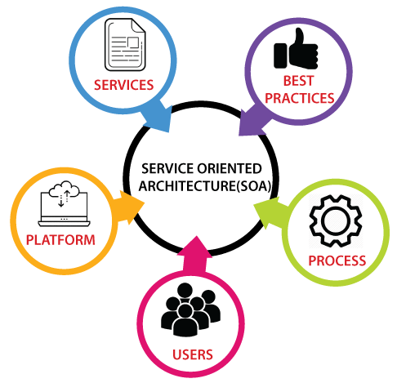

## Grid Computing

Grid computing is also known as **distributed computing**. It is a processor architecture that combines various different computing resources from multiple locations to achieve a common goal. In grid computing, the grid is connected by parallel nodes to form a computer cluster. These computer clusters are in different sizes and can run on any operating system.

Grid computing contains the following three types of machines -

1. **Control Node:** It is a group of server which administrates the whole network.
2. **Provider:** It is a computer which contributes its resources in the network resource pool.
3. **User:** It is a computer which uses the resources on the network.

Mainly, grid computing is used in the **ATMs, back-end infrastructures,** and **marketing research**.

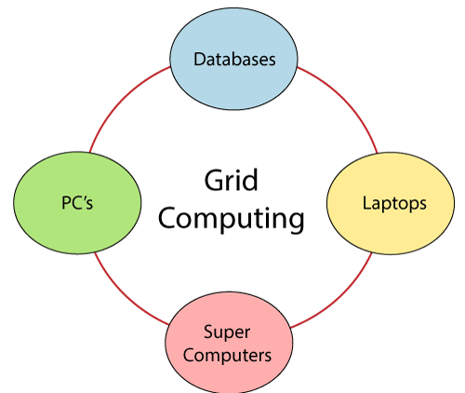

## Utility Computing

Utility computing is the most trending IT service model. It provides on-demand computing resources (computation, storage, and programming services via API) and infrastructure based on the **pay per use** method. It minimizes the associated costs and maximizes the efficient use of resources. The advantage of utility computing is that it reduced the IT cost, provides greater flexibility, and easier to manage.

Large organizations such as **Google** and **Amazon** established their own utility services for computing storage and application.

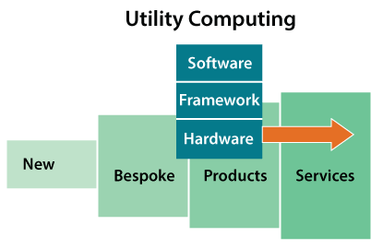

# **How does cloud computing work**

Assume that you are an executive at a very big corporation. Your particular responsibilities include to make sure that all of your employees have the right hardware and software they need to do their jobs. To buy computers for everyone is not enough. You also have to purchase software as well as software licenses and then provide these softwares to your employees as they require. Whenever you hire a new employee, you need to buy more software or make sure your current software license allows another user. It is so stressful that you have to spend lots of money.

But, there may be an alternative for executives like you. So, instead of installing a suite of software for each computer, you just need to load one application. That application will allow the employees to log-in into a Web-based service which hosts all the programs for the user that is required for his/her job. Remote servers owned by another company and that will run everything from e-mail to word processing to complex data analysis programs. It is called cloud computing, and it could change the entire computer industry.

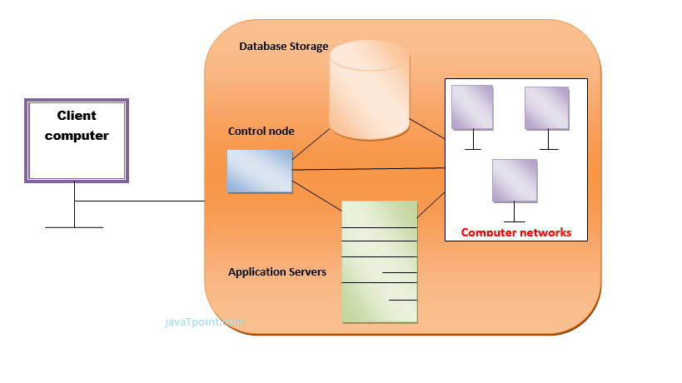

In a cloud computing system, there is a significant workload shift. Local computers have no longer to do all the heavy lifting when it comes to run applications. But cloud computing can handle that much heavy load easily and automatically. Hardware and software demands on the user's side decrease. The only thing the user's computer requires to be able to run is the cloud computing interface software of the system, which can be as simple as a Web browser and the cloud's network takes care of the rest.

# **Types of Cloud**

There are the following 4 types of cloud that you can deploy according to the organization's needs-

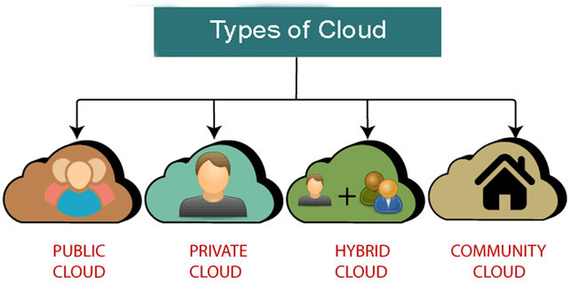

* [Public Cloud](https://www.javatpoint.com/types-of-cloud#Public)
* [Private Cloud](https://www.javatpoint.com/types-of-cloud#Private)
* [Hybrid Cloud](https://www.javatpoint.com/types-of-cloud#Hybrid)
* [Community Cloud](https://www.javatpoint.com/types-of-cloud#Community)

## Public Cloud

Public cloud is **open to all** to store and access information via the Internet using the pay-per-usage method.

In public cloud, computing resources are managed and operated by the Cloud Service Provider (CSP).

**Example:** Amazon elastic compute cloud (EC2), IBM SmartCloud Enterprise, Microsoft, Google App Engine, Windows Azure Services Platform.

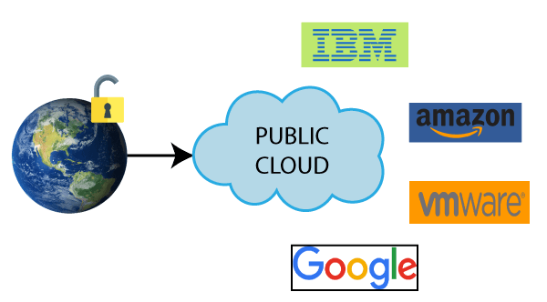

### **Advantages of Public Cloud**

There are the following advantages of Public Cloud -

* Public cloud is owned at a lower cost than the private and hybrid cloud.
* Public cloud is maintained by the cloud service provider, so do not need to worry about the maintenance.
* Public cloud is easier to integrate. Hence it offers a better flexibility approach to consumers.
* Public cloud is location independent because its services are delivered through the internet.
* Public cloud is highly scalable as per the requirement of computing resources.
* It is accessible by the general public, so there is no limit to the number of users.

### **Disadvantages of Public Cloud**

* Public Cloud is less secure because resources are shared publicly.
* Performance depends upon the high-speed internet network link to the cloud provider.
* The Client has no control of data.

**To Read More** [**Click Here**](https://www.javatpoint.com/public-cloud)

## Private Cloud

Private cloud is also known as an **internal cloud** or **corporate cloud**. It is used by organizations to build and manage their own data centers internally or by the third party. It can be deployed using Opensource tools such as Openstack and Eucalyptus.

Based on the location and management, National Institute of Standards and Technology (NIST) divide private cloud into the following two parts-

* On-premise private cloud
* Outsourced private cloud

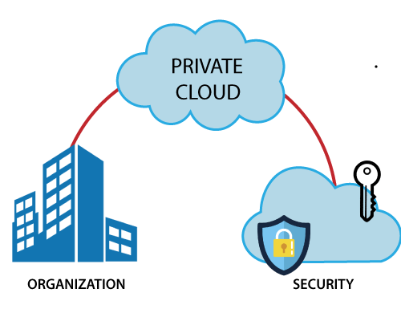

### **Advantages of Private Cloud**

There are the following advantages of the Private Cloud -

* Private cloud provides a high level of security and privacy to the users.
* Private cloud offers better performance with improved speed and space capacity.
* It allows the IT team to quickly allocate and deliver on-demand IT resources.
* The organization has full control over the cloud because it is managed by the organization itself. So, there is no need for the organization to depends on anybody.
* It is suitable for organizations that require a separate cloud for their personal use and data security is the first priority.

### **Disadvantages of Private Cloud**

* Skilled people are required to manage and operate cloud services.
* Private cloud is accessible within the organization, so the area of operations is limited.
* Private cloud is not suitable for organizations that have a high user base, and organizations that do not have the prebuilt infrastructure, sufficient manpower to maintain and manage the cloud.

**To Read More** [**Click Here**](https://www.javatpoint.com/private-cloud)

## Hybrid Cloud

Hybrid Cloud is a combination of the public cloud and the private cloud. we can say:

**Hybrid Cloud = Public Cloud + Private Cloud**

Hybrid cloud is partially secure because the services which are running on the public cloud can be accessed by anyone, while the services which are running on a private cloud can be accessed only by the organization's users.

**Example:** Google Application Suite (Gmail, Google Apps, and Google Drive), Office 365 (MS Office on the Web and One Drive), Amazon Web Services.

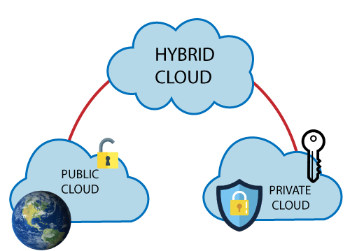

### **Advantages of Hybrid Cloud**

There are the following advantages of Hybrid Cloud -

* Hybrid cloud is suitable for organizations that require more security than the public cloud.
* Hybrid cloud helps you to deliver new products and services more quickly.
* Hybrid cloud provides an excellent way to reduce the risk.
* Hybrid cloud offers flexible resources because of the public cloud and secure resources because of the private cloud.

### **Disadvantages of Hybrid Cloud**

* In Hybrid Cloud, security feature is not as good as the private cloud.
* Managing a hybrid cloud is complex because it is difficult to manage more than one type of deployment model.
* In the hybrid cloud, the reliability of the services depends on cloud service providers.

**To Read More** [**Click Here**](https://www.javatpoint.com/hybrid-cloud)

## Community Cloud

Community cloud allows systems and services to be accessible by a group of several organizations to share the information between the organization and a specific community. It is owned, managed, and operated by one or more organizations in the community, a third party, or a combination of them.

**Example:** Health Care community cloud

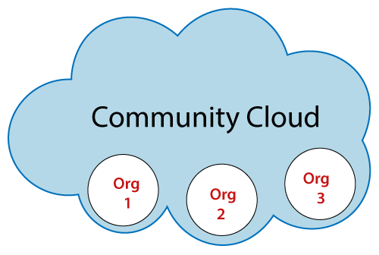

### **Advantages of Community Cloud**

There are the following advantages of Community Cloud -

* Community cloud is cost-effective because the whole cloud is being shared by several organizations or communities.
* Community cloud is suitable for organizations that want to have a collaborative cloud with more security features than the public cloud.
* It provides better security than the public cloud.
* It provdes collaborative and distributive environment.
* Community cloud allows us to share cloud resources, infrastructure, and other capabilities among various organizations.

### **Disadvantages of Community Cloud**

* Community cloud is not a good choice for every organization.
* Security features are not as good as the private cloud.
* It is not suitable if there is no collaboration.
* The fixed amount of data storage and bandwidth is shared among all community members.

# **Cloud Service Models**

There are the following three types of cloud service models -

1. [Infrastructure as a Service (IaaS)](https://www.javatpoint.com/cloud-service-models#IaaS)
2. [Platform as a Service (PaaS)](https://www.javatpoint.com/cloud-service-models#PaaS)
3. [Software as a Service (SaaS)](https://www.javatpoint.com/cloud-service-models#SaaS)

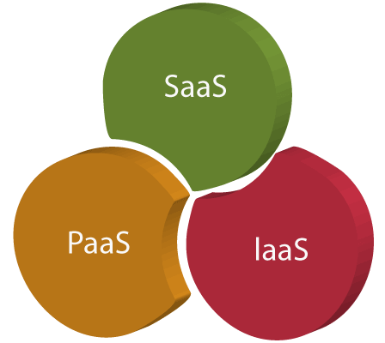

## Infrastructure as a Service (IaaS)

IaaS is also known as **Hardware as a Service (HaaS)**. It is a computing infrastructure managed over the internet. The main advantage of using IaaS is that it helps users to avoid the cost and complexity of purchasing and managing the physical servers.

### **Characteristics of IaaS**

There are the following characteristics of IaaS -

* Resources are available as a service
* Services are highly scalable
* Dynamic and flexible
* GUI and API-based access
* Automated administrative tasks

**Example:** DigitalOcean, Linode, Amazon Web Services (AWS), Microsoft Azure, Google Compute Engine (GCE), Rackspace, and Cisco Metacloud.

To know more about the IaaS, [**click here**](https://www.javatpoint.com/infrastructure-as-a-service).

## Platform as a Service (PaaS)

PaaS cloud computing platform is created for the programmer to develop, test, run, and manage the applications.

### **Characteristics of PaaS**

There are the following characteristics of PaaS -

* Accessible to various users via the same development application.
* Integrates with web services and databases.
* Builds on virtualization technology, so resources can easily be scaled up or down as per the organization's need.
* Support multiple languages and frameworks.
* Provides an ability to "**Auto-scale**".

**Example:** AWS Elastic Beanstalk, Windows Azure, Heroku, Force.com, Google App Engine, Apache Stratos, Magento Commerce Cloud, and OpenShift.

To know more about PaaS, [click here](https://www.javatpoint.com/platform-as-a-service).

## Software as a Service (SaaS)

SaaS is also known as "**on-demand software**". It is a software in which the applications are hosted by a cloud service provider. Users can access these applications with the help of internet connection and web browser.

### **Characteristics of SaaS**

There are the following characteristics of SaaS -

* Managed from a central location
* Hosted on a remote server
* Accessible over the internet
* Users are not responsible for hardware and software updates. Updates are applied automatically.
* The services are purchased on the pay-as-per-use basis

**Example:** BigCommerce, Google Apps, Salesforce, Dropbox, ZenDesk, Cisco WebEx, ZenDesk, Slack, and GoToMeeting.

To know more about the SaaS, [**click here**](https://www.javatpoint.com/software-as-a-service).

## Difference between IaaS, PaaS, and SaaS

The below table shows the difference between IaaS, PaaS, and SaaS -

|  |  |  |
| --- | --- | --- |
| **IaaS** | **Paas** | **SaaS** |
| It provides a virtual data center to store information and create platforms for app development, testing, and deployment. | It provides virtual platforms and tools to create, test, and deploy apps. | It provides web software and apps to complete business tasks. |
| It provides access to resources such as virtual machines, virtual storage, etc. | It provides runtime environments and deployment tools for applications. | It provides software as a service to the end-users. |
| It is used by network architects. | It is used by developers. | It is used by end users. |
| IaaS provides only Infrastructure. | PaaS provides Infrastructure+Platform. | SaaS provides Infrastructure+Platform +Software. |

# **Cloud Service Models**

There are the following three types of cloud service models -

1. [Infrastructure as a Service (IaaS)](https://www.javatpoint.com/cloud-service-models#IaaS)
2. [Platform as a Service (PaaS)](https://www.javatpoint.com/cloud-service-models#PaaS)
3. [Software as a Service (SaaS)](https://www.javatpoint.com/cloud-service-models#SaaS)



## Infrastructure as a Service (IaaS)

IaaS is also known as **Hardware as a Service (HaaS)**. It is a computing infrastructure managed over the internet. The main advantage of using IaaS is that it helps users to avoid the cost and complexity of purchasing and managing the physical servers.

### **Characteristics of IaaS**

There are the following characteristics of IaaS -

* Resources are available as a service
* Services are highly scalable
* Dynamic and flexible
* GUI and API-based access
* Automated administrative tasks

**Example:** DigitalOcean, Linode, Amazon Web Services (AWS), Microsoft Azure, Google Compute Engine (GCE), Rackspace, and Cisco Metacloud.

To know more about the IaaS, [**click here**](https://www.javatpoint.com/infrastructure-as-a-service).

## Platform as a Service (PaaS)

PaaS cloud computing platform is created for the programmer to develop, test, run, and manage the applications.

### **Characteristics of PaaS**

There are the following characteristics of PaaS -

* Accessible to various users via the same development application.
* Integrates with web services and databases.
* Builds on virtualization technology, so resources can easily be scaled up or down as per the organization's need.
* Support multiple languages and frameworks.
* Provides an ability to "**Auto-scale**".

**Example:** AWS Elastic Beanstalk, Windows Azure, Heroku, Force.com, Google App Engine, Apache Stratos, Magento Commerce Cloud, and OpenShift.

To know more about PaaS, [click here](https://www.javatpoint.com/platform-as-a-service).

## Software as a Service (SaaS)

SaaS is also known as "**on-demand software**". It is a software in which the applications are hosted by a cloud service provider. Users can access these applications with the help of internet connection and web browser.

### **Characteristics of SaaS**

There are the following characteristics of SaaS -

* Managed from a central location
* Hosted on a remote server
* Accessible over the internet
* Users are not responsible for hardware and software updates. Updates are applied automatically.
* The services are purchased on the pay-as-per-use basis

**Example:** BigCommerce, Google Apps, Salesforce, Dropbox, ZenDesk, Cisco WebEx, ZenDesk, Slack, and GoToMeeting.

To know more about the SaaS, [**click here**](https://www.javatpoint.com/software-as-a-service).

## Difference between IaaS, PaaS, and SaaS

The below table shows the difference between IaaS, PaaS, and SaaS -

|  |  |  |
| --- | --- | --- |
| **IaaS** | **Paas** | **SaaS** |
| It provides a virtual data center to store information and create platforms for app development, testing, and deployment. | It provides virtual platforms and tools to create, test, and deploy apps. | It provides web software and apps to complete business tasks. |
| It provides access to resources such as virtual machines, virtual storage, etc. | It provides runtime environments and deployment tools for applications. | It provides software as a service to the end-users. |
| It is used by network architects. | It is used by developers. | It is used by end users. |
| IaaS provides only Infrastructure. | PaaS provides Infrastructure+Platform. | SaaS provides Infrastructure+Platform +Software. |

# **Virtualization in Cloud Computing**

**Virtualization** is the "creation of a virtual (rather than actual) version of something, such as a server, a desktop, a storage device, an operating system or network resources".

In other words, Virtualization is a technique, which allows to share a single physical instance of a resource or an application among multiple customers and organizations. It does by assigning a logical name to a physical storage and providing a pointer to that physical resource when demanded.

## What is the concept behind the Virtualization?

Creation of a virtual machine over existing operating system and hardware is known as Hardware Virtualization. A Virtual machine provides an environment that is logically separated from the underlying hardware.

The machine on which the virtual machine is going to create is known as **Host Machine** and that virtual machine is referred as a **Guest Machine**

## Types of Virtualization:

1. Hardware Virtualization.
2. Operating system Virtualization.
3. Server Virtualization.
4. Storage Virtualization.

### **1) Hardware Virtualization:**

When the virtual machine software or virtual machine manager *(VMM) is directly installed on the hardware system* is known as hardware virtualization.

The main job of hypervisor is to control and monitoring the processor, memory and other hardware resources.

After virtualization of hardware system we can install different operating system on it and run different applications on those OS.

**Usage:**

Hardware virtualization is mainly done for the server platforms, because controlling virtual machines is much easier than controlling a physical server.

### **2) Operating System Virtualization:**

When the virtual machine software or virtual machine manager *(VMM) is installed on the Host operating system* instead of directly on the hardware system is known as operating system virtualization.

**Usage:**

Operating System Virtualization is mainly used for testing the applications on different platforms of OS.

### **3) Server Virtualization:**

When the virtual machine software or virtual machine manager *(VMM) is directly installed on the Server system* is known as server virtualization.

**Usage:**

Server virtualization is done because a single physical server can be divided into multiple servers on the demand basis and for balancing the load.

### **4) Storage Virtualization:**

Storage virtualization is the *process of grouping the physical storage from multiple network storage devices so that it looks like a single storage device*.

Storage virtualization is also implemented by using software applications.

**Usage:**

Storage virtualization is mainly done for back-up and recovery purposes.

## How does virtualization work in cloud computing?

**Virtualization** plays a very important role in the cloud computing technology, normally in the cloud computing, users share the data present in the clouds like application etc, but actually with the help of virtualization users shares the Infrastructure.

The **main usage of Virtualization Technology** is to provide the applications with the standard versions to their cloud users, suppose if the next version of that application is released, then cloud provider has to provide the latest version to their cloud users and practically it is possible because it is more expensive.

To overcome this problem we use basically virtualization technology, By using virtualization, all severs and the software application which are required by other cloud providers are maintained by the third party people, and the cloud providers has to pay the money on monthly or annual basis.

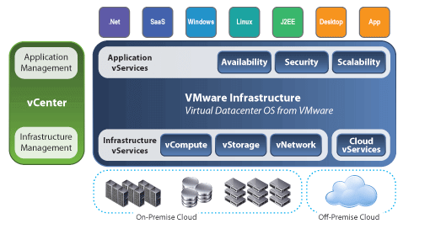

## Conclusion

Mainly Virtualization means, running multiple operating systems on a single machine but sharing all the hardware resources. And it helps us to provide the pool of IT resources so that we can share these IT resources in order get benefits in the business.